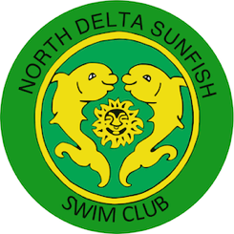
NORTH DELTA SUNFISH SWIM CLUB
7184 – 120th Street, Box 591, Surrey, B.C. V3W 0M6
www.northdeltasunfish.ca

Donation Form

Swimmer’s name |  |  | Telephone:
Donator Business name:

Mailing & street address of business:

Business Telephone: |  | Fax:
Contact name: |  | Telephone:
Alternate contact: |  | Telephone:
Business Email address:

Business Website URL:

Business description:

Company Logo attached? | - Yes, hard copy attached in appropriate size (1/4, 1/2 or full page)  - Yes, electronic copy emailed to: fundraising@ndsunfish.com
Donation package  (check one)  Total commitment:  $ __________________  (payable to: North Delta Sunfish) | - Club Supporter $0-$99 Sunfish Invitational Swim Meet  - Bronze $100-$249  Event $50  - Silver $250-$499  Lane $250  - Gold $500-$999  Single Business Card $75  - Platinum $1000-$1999  Single ½ Page Ad $100  - Diamond $2000+  Single Full Page Ad $250  (includes Full Swim Meet Sponsorship)
Authorizing signature |  |  | Date:

