Super 7
Meet Package

Ladner Stingrays Swim Club
Super 7 Meet Package

Saturday & Sunday, June 17th & 18th , 2023

This is the 11th Anniversary of the Ladner Stingrays Super 7. We are happy to be returning after a three year break due to the COVID-19 pandemic and hosting our meet at Watermania. The Super 7 takes place early in the season and swimmers need as many chances as possible to race in all of the strokes, which is why we have structured this meet so that swimmers can swim all strokes over the 2 days. In addition, most swimmers can swim any distance; you are NOT limited by your division (i.e. a Div. 3 swimmer can swim both the 50M and 100M Backstroke). The heats have been scheduled so that swimmers who choose to swim both distances in the same stroke will not have to do so on the same day.

Relays are supposed to be a fun part of the meet, so we want you to get your favorite team together, whether it includes your sister, your coach or even a friend from another team. Winning the relay will require coming closest to your entry time. Prizes will be awarded to the first, second and third place relay teams. Each swimmer can only do one relay. This year we have a Mixed 200 Metre Freestyle on Saturday, there will be no mixed Medley relay this year.

Aggregates will be awarded to first, second, and third place by division and gender. Heats will be swum with all divisions swimming together (seeded by time). The meet does start later (9:10 am) and hopefully end early.
Deadline for meet entries is 7pm Friday, June 2(or earlier).

LOCATION
Watermania
14300 Entertainment Blvd., Richmond, BC
Map

FACILITIES
- Indoor – 8 Lane 25m pool. Extra 6 lanes for morning warm up
- 2 lanes for all day warm up and cool down
- Public washrooms inside Watermania; Porta Potties outside
- Lots of Bleacher Seating
- Ample space outside of the pool for Team Tents and Pop–Ups
- Lots of parking is available, but please refrain from parking in the Extreme Air Park lot.
- Pop-ups are also not permitted on the grassy islands surrounding the Extreme Air Park lot. See below for the map for permitted pop-up areas.
- RV parking in the Richmond Ice parking lot

Pop-Up/RV/Parking

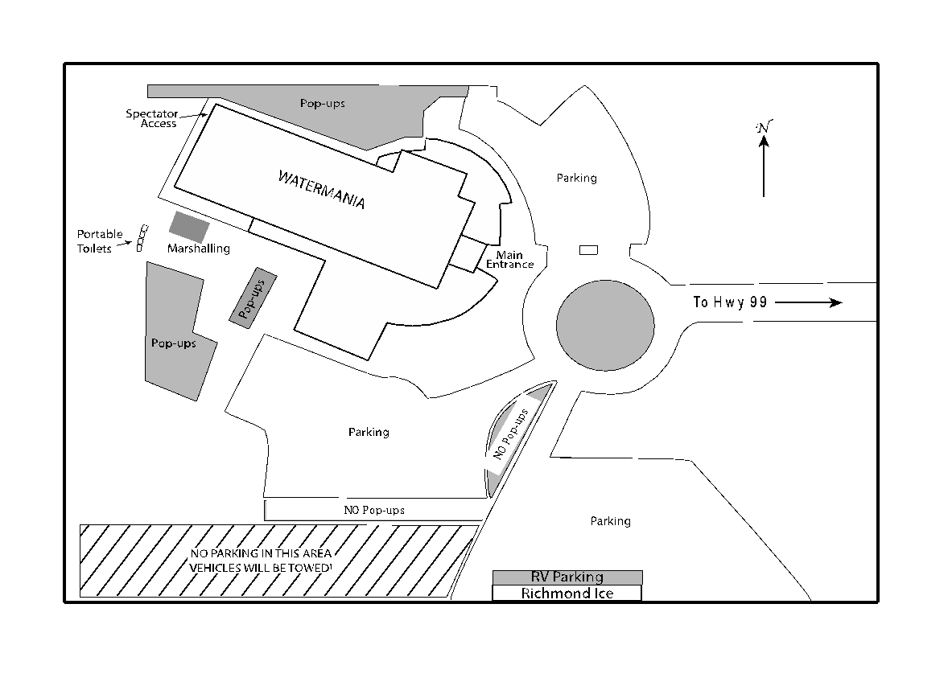

FOOD
There are a number of restaurants nearby: Watermania Concession, Monkey 9 Brewing Co, Stanley’s Sports Bar and Grill, Subway, and the Old Spaghetti Factory.

Additional food options are being worked on as the Stingrays Breakfast Will Not be offered this year.

ACCOMMODATION
- Should you require RV parking please contact Super7@ladnerstingrays.com by June 7, 7pm.

Holiday Inn Express Hotel & Suites Riverport

If you are planning on staying at the Holiday Inn they can be contacted at:
- 10688 No.6 Road
- Richmond, BC V6W 1E7
- 604.241.1830 | +1 (877) 660-8550 | Fax: 604.241.184

FEES
- Two days = $50.00 per swimmer (up to 7 events and 1 relay)
- One day = $35.00 per swimmer (up to 5 events and 1 relay)
  - Note: This fee structure is beneficial for all clubs whether their swimmers compete for one day or two. This is a very good deal!
- The 25 metre Freestyle and Backstroke for 6 & under swimmers are free.
- Please submit payment for your meet fees to the on Deck Office prior to meet start time on Saturday, June 17. Make cheques payable to: Ladner Stingrays
- Programs will be available for $5 each.

ENTRIES
- Must be in by 7:00 pm Friday, June 2, 2023 (or earlier if possible)
- DUE TO LIMITED POOL SPACE AND TIME, ENTRIES WILL BE LIMITED TO 600 SWIMMERS. Get your entries in early.
- Email entries to meetentries@ladnerstingrays.com. If you do not receive an email confirmation within 24 hours, then we did not receive your entries.
- Please submit all entries in HYTEK FORMAT
- Submit BCSSA Meet Entry Form and Validation List.
- Ensure all NTs have an approximate, but realistic time, so that the meet can proceed efficiently
- Submit your relay time estimate for seeding purposes. Times can be changed the day of the event on the relay cards
- Clubs with a large number of relay teams must have an experienced coach in marshalling to help ensure their swimmers are on the right teams
- Relay cards must be submitted by 10am on Saturday
- Submit name and telephone number of your club's computer contact person.

INFO for COACHES
- Please bring a refillable water bottle.
- Scratches are to be submitted BY COACHES to the Clerk of the Course no later than 8:30am
- No refunds for scratches.
- THERE WILL BE NO DECK ENTRIES
- Submit your relay teams no later than 10am on Saturday
- Ensure that your swimmers can swim the distance they are entered in and have a reasonable chance of being able to complete the event (Many DQ’s will delay the event)
- Please ensure all HY-Tek entries submitted contain NO NTs.

FORMAT
- 6 & Under events will only take place on the Saturday
- 200m Free events are reserved for Divisions 4 and up.
- 200m IM events are reserved for Divisions 3 and up.
- Heats will be swum as timed finals
- Swimmers will be seeded by time, not by division
- Swimmers may enter 7 events and a relay
- This will be a cardless meet with marshalling
- 2023 BCSSA rules for swimming apply in addition to the latest rule changes
- Relays will be totally open as to age and gender. Awards will be given for closest to seed times (i.e. entry time 2:13.10 – actual time 2:13.09) a tie goes to below seedtime.

SCHEDULE
Saturday
Warm-ups: 8:00–8:40am
Officials meeting: 8:15am
Scratches Submitted: 8:30am (no later)
Coaches meeting: 8:40am
Cheers & O’Canada: 8:50-9:00am
Marshaling begins: 9:00am
Heats begin: 9:10am
Relay Cards Submitted: 10:00am (no later Saturday only)

Sunday (this year Sunday will start 15 minutes later than Saturday)
Warm-ups: 8:15-8:55am
Officials Meeting 8:30am
Coaches meeting: 8:55am
Cheers & O’Canada: 9:05- 9:15am
Marshalling begins: 9:15am
Heats begin: 9:25am

AWARDS
- 1st, 2nd, and 3rd place aggregate awards for “S” and “O” Cat swimmers for each Division Male and Female. Scoring format is the 9 point system (9,7,6,5,4,3,2,1), so a maximum of 63 points (9 x 7).
- Relay awards will be based on closest to seedtime with under beating over on a tie.
- Only the overall 1st, 2nd, and 3rd place Relay team will get awards.
- 6 and under swimmers will receive a goody bag.

OFFICIALS
  - Each club will be required to supply timers, recorders and deck officials.
  - We will have a Designated Disqualifying Official (DDO) who is responsible for disqualifications. All Stroke & Turn Judges will still need to ensure the starter/ref signs off on the DQ slips, but from there, the DDO will take the DQs to the coaches, and the coaches will inform the swimmer of their infraction.

  - A sign-up schedule will be provided in the week leading up to the meet.

Please bring a refillable water bottle

TIMING SYSTEM
- Omega Timing System (Ares) will be used as the automatic judging and timing system in accordance with the BCSSA rules.
- Two electronic plungers per lane will back up the automatic timing system.
- One lane timer and one recorder will each operate a plunger.
- Should the automatic judging and timing system fail for an extended period of time, the meet will proceed with manual timing (2 stopwatches with “starting gun”)

If you have any questions regarding this meet,
please contact
Tanja or Mike at Super7@ladnerstingrays.com

The Ladner Stingrays look forward to your participation in our Meet!

LADNER STINGRAYS SUPER 7 SWIM MEET EVENT LIST

WARMS UPS: 8:00 – 8:40 AM
MARSHALING BEGINS: 9:00 AM
MEET COMMENCES: 9:10 AM
(PLEASE NOTE:SUNDAY WILL START 15 MINUTES LATER THAN SATURDAY)
Saturday June 17th | Sunday June 18th
- Girls 200 IM (Div.3 & up)  - Boys 200 IM (Div.3 & up)  - Girls 50 Free  - Boys 50 Free  - Girls 6 & under 25 Free  - Boys 6 & under 25 Free  - Girls 100 backstroke  - Boys 100 Backstroke  - Girls 6 & under 25 back  - Boys 6 & under 25 back  - Girls 50 Breaststroke  - Boys 50 Breaststroke  - Girls 100 Butterfly  - Boys 100 Butterfly  - Mixed 200 Free Relay | - Girls 100 IM  - Boys 100 IM  - Girls 50 Butterfly  - Boys 50 Butterfly  - Girls 200 Free (Div. 4 & up)  - Boys 200 Free (Div. 4 & up)  - Girls 100 Breaststroke  - Boys 100 Breaststroke  - Girls 50 Backstroke  - Boys 50 Backstroke  - Girls 100 Freestyle  - Boys 100 Freestyle

